# Lecture 5 - 棋牌类: Black Jack & Chinese Chess

## 棋牌类解题思路

* 特点 - Clarify
  + 玩家
  + 规则
  + 胜负
  + 积分
* 术语 - Core Object
  + Board
  + Suit
  + Hand
* State - Use Case
  + Initialization (摆盘，洗牌...)
  + Play (下棋，出牌...)
  + Win/Lose check (胜负结算) + Tie (流局)

### TicTacToe

//Simulator.java

makeMove(1,1)

//TicTacToe.java

public void makeMove(int row, int col) {

board.makeMove(row, col, currentMove);

if (board.checkWin()) {

print (currentMove + " win!");

} else if (board.isBoardFull()) {

print("It's a tie");

}

changePlayer();

}

### Chinese Chess

* 特点 - Clarify
  + 玩家
  + 规则
  + 胜负
  + 积分
* 术语 - Core Object
  + Board
  + Suit
  + Hand
* State - Use Case
  + Initialization (摆盘，洗牌...)
  + Play (下棋，出牌...)
  + Win/Lose check (胜负结算) + Tie (流局)

### 牌类 - Blackjack

* Core Objects - 牌类较为固定的framework
  + Hand, Player, Dealer, Card, Deck
* Use Case
  + Initialization (摆盘，洗牌...)
    - Join table
    - Place bet
    - Get initial cards
  + Play (下棋，出牌...)
    - Deal
    - Increase bet
    - Stop dealing
  + Win/Lose check (胜负结算) + Tie / Draw (平局)
    - Compare score
    - Take/Lose bets

solution1简单很多，最好用这个

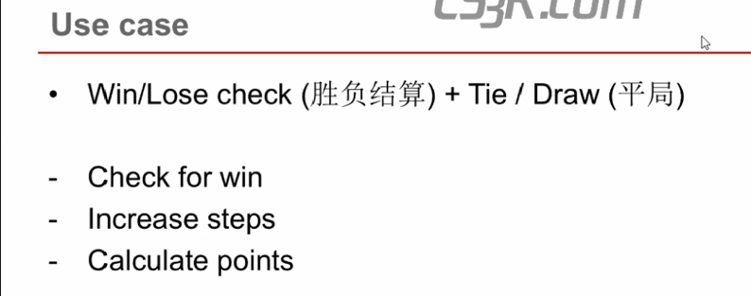

**blackjack**

只有棋牌类才加player这个类



